Name: Elvia Gisella Adair
Assignment: Django Basics

Django installment
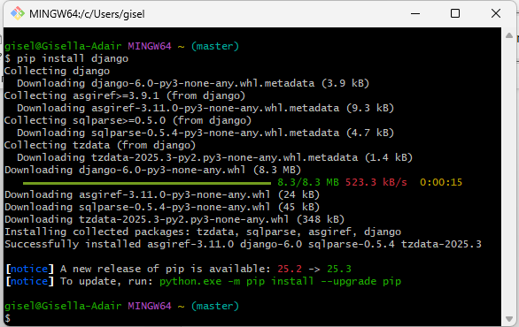

open up a browser window and type in the address 127.0.0.1:8000 and take a screenshot of the page

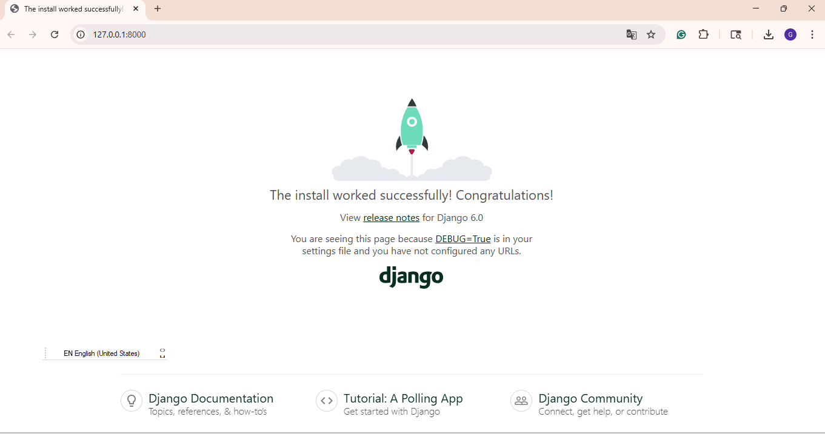

If you go out to your local host and see <your last name>" says Hello!, then congratulations! Take a screenshot. Paste that screenshot into your Word document

